

**Vehicle Fleet Management**

University of Wisconsin-Madison

Department of Industrial and Systems Engineering

ISYE 645

__________________________________________________________

Group 2

1. Kashyap Sarda
2. Pujan Parvadia
3. Purvang Shah

12/9/2022

**Table of Contents**

1. Introduction
2. Problem Statement
3. Objective
4. Methodology
5. Results
6. Conclusion

**1. Introduction**

Vehicle fleet management is a series of complex tasks that keep a business of transporting vehicles productively and generating revenue. When a fleet is managed correctly, the operation cost is reduced, drivers are safe, and customers are happy.

Fleet management tools can help fleet managers gain real-time visibility into their operations while increasing driver satisfaction and decreasing fuel usage through predictive analytics and accurate reporting.

Challenges:

To effectively manage a fleet, an organization needs to forecast how many and what type of vehicles a fleet will need to operate efficiently. It might seem straightforward to purchase new vehicles when the need arises, but correctly understanding and forecasting fleet vehicle utilization is paramount in correctly determining a purchase strategy. Employee eligibility for a vehicle class, vehicle lifecycle, and even market timing are all significant factors that need to be considered while shaping vehicle acquisition strategy.

**2. Problem statement**

A fleet of 60 vehicles (30 at A and 30 at B) is available, and the customer demand follows Poisson distribution and varies for each station and each hour of the day.

The profit value and vehicle relocation cost are different; however, the penalty for backorder is the same for both.

Given data:

Relocation cost of the vehicle from A to B = $20

Relocation cost of the vehicle from B to A = $30

Travel time from A to B = 2 hours

Travel time from B to A = 3 hours

Reward for customer satisfaction from A to B = $60

Reward for customer satisfaction from B to A = $90

Penalty for backorder = $100

**3. Objective**

Apply different inventory policies and select the policy that satisfies the maximum number of customers and provides the highest mean profit while ensuring that the total vehicles in the system remain at 60 at any given hour.

**4. Methodology**

The mean customer demand for each hour and the station was given, and it follows a Poisson distribution. According to that, we generated samples to test the different policies and determine the average profit using all the samples. The best policy was then determined based on the highest average profit.

Since the demand follows a poisson distribution, the “**np.random.poisson”** function was used to generate random demand from the mean, and the “**random.choice”** function was used to select a random value from it in python and code for it is included in Appendix A.1. Examples of randomly generated samples can be seen in Fig A.1.

In a total hundred samples, customer demand was generated using the given mean demand and stored in a list. The samples were then indexed for each policy, and the profit obtained from it was calculated and stored in a list using the below formula.

Profit = ca*60+cb*90-pa*100-pb*100-ma*20-mb*30 where:

ca = customers satisfied at station A

cb = customers satisfied at station B

pa = back-order at station A

pb = back-order at station B

ma = vehicles relocated from station A

mb = vehicles relocated from station B

**4.1. Policy development**

**4.1.1. No Policy**

In no policy, we decided not to reallocate any vehicles, and the system was allowed to run independently. The code can be found in appendix A.3.

The figure below depicts the calculation on the given sample. Mov a2b and Mov b2a are the vehicles relocated from stations A and B, respectively. They are zero throughout the day because no policy is applied in this case. The vehicles in the system are the sum of the available inventory at A and B and the vehicles in transit from A and B. As mentioned above, cust a and cust b is customer satisfaction at A and customer satisfaction at B.

Calculation on given sample data:

Calculation for a few hours is shown below. All 24 hours calculations can be seen in appendix A.4.

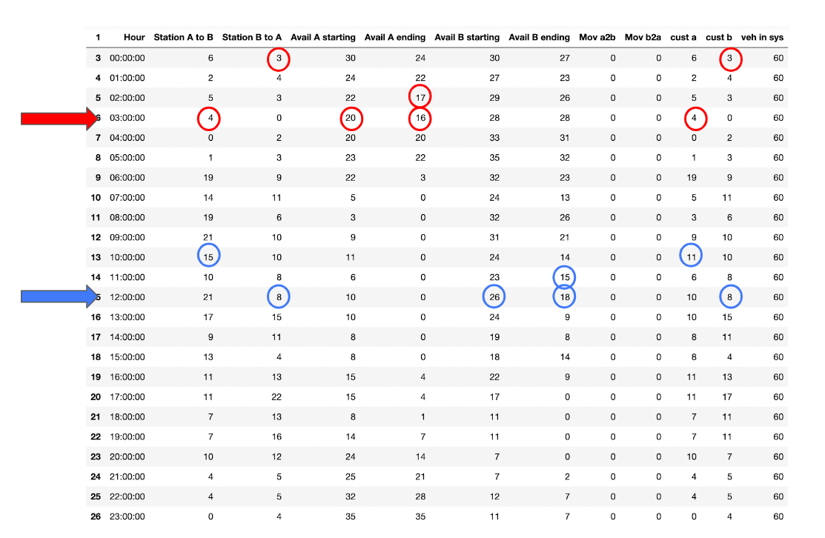

Calculation on randomly generated sample data:

Calculation for a few hours is shown below. All 24 hours calculations can be seen in appendix A.5.

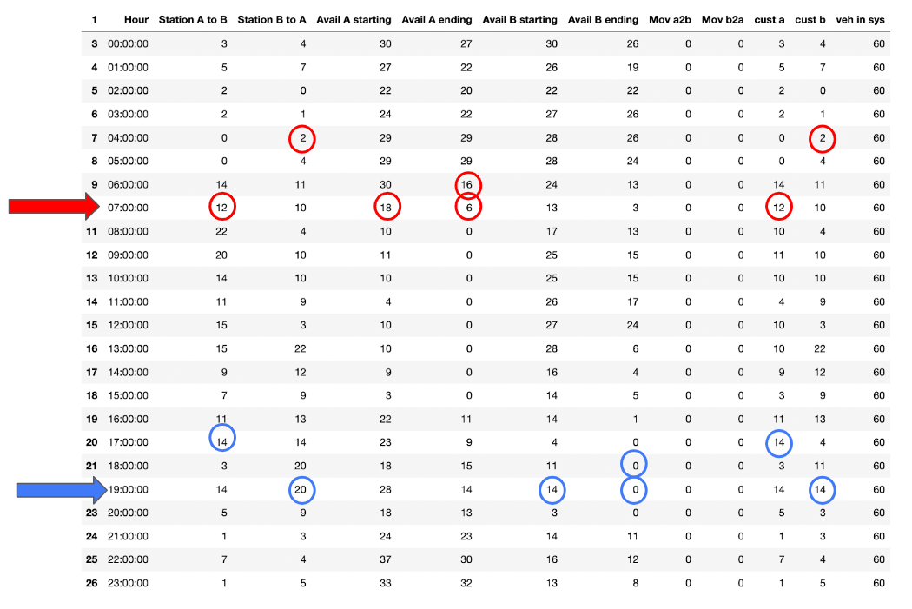

The summary of this policy is shown in the table below:

| Station | A | B |
| --- | --- | --- |
| Total Customer | 230 | 197 |
| Customer Satisfied | 161 | 180 |
| Customer Satisfaction (%) | 70.00% | 91.37% |
| Average Satisfaction (%) | 79.85% | |

**4.1.2. S, T policy using base stock**

**Calculation for vehicle movement from A and B stations:**

The base stock value is denoted as **s** and is given by

s = μDLTR+ Z𝛂 𝛔DLTR, i.e.,

s = μD(μL+T)+Z𝛂 𝛔D√(μL+T)

Where,

μD = mean demand

μL = lead time

T = review period

𝛂 = service level

𝛔D = standard deviation of demand

**Condition:**

If the vehicles available after meeting the demand for that hour were greater than the required base stock level, the excess vehicles were moved to the next station. The code can be seen in appendix A.6.

The figure below depicts the calculation on the given sample using the base stock policy with a service level of 99% and 2 hours of the review period. Sab and Sba are the base stock values determined using the given mean demand for each hour and station. Mov a2b are the vehicles relocated from station A if the available inventory A after meeting the demand for that hour is greater than Sab. The vehicles in the system are the sum of the available inventory at A and B and the vehicles in transit from A and B.

Calculation on given sample data:

Calculation on given sample data for a few hours is shown below. All 24 hours calculations can be seen in appendix A.7.

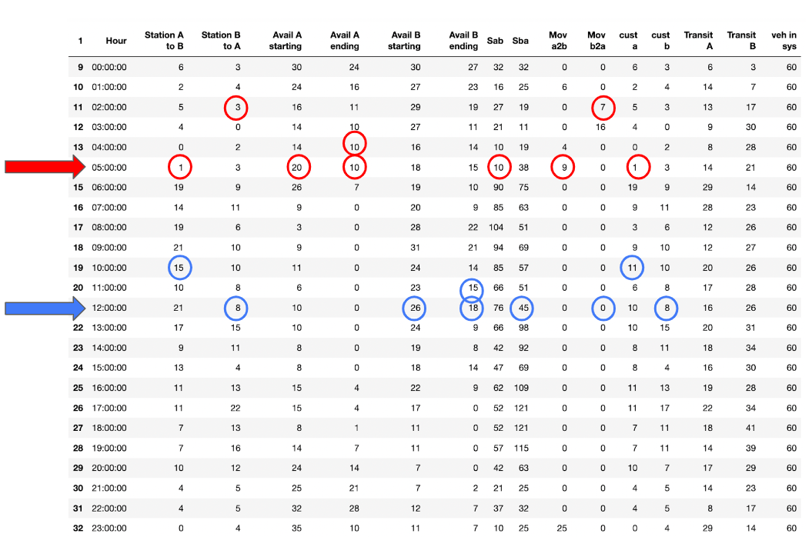

Calculation on randomly generated sample data:

Calculation on randomly generated sample data for a few hours is shown below. All 24 hours calculations can be seen in appendix A.8.

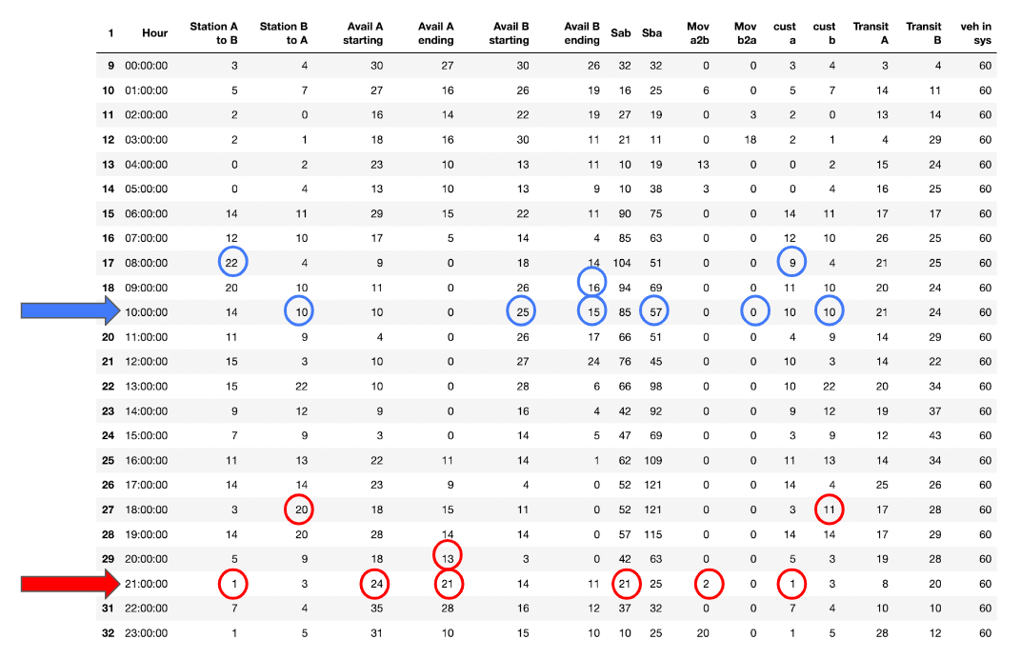

The summary of this policy is shown in the table below:

We tried multiple iterations with a service level of 80%, 90%, 95% and 99% and Review period of 1,2 and 3 hours. From the below table we can clearly say that highest profit and customer satisfaction can be achieved with 99% service level and 2 hrs of review period. 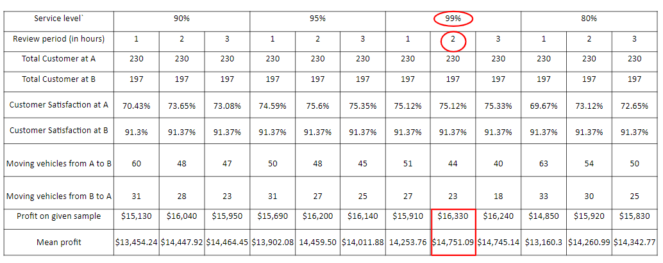

**4.1.3. S, T policy using average stock value**

Estimate average on-hand inventory = (μDT)/2 + n̅(s), where

n̅(s) = (Z𝛂 + L(Z))𝛔DLTR

**Condition:**

If the vehicle available after meeting the demand were greater than the required average inventory, the excess vehicles were moved to the next station. The code can be found in appendix A.9.

The figure shown below depicts the calculation on the given sample using the base stock policy. Avg inv ab and Avg inv ba are the average stock values determined using the given mean demand for each hour and station. Mov a2b are the vehicles relocated from station A if the available inventory A after meeting the demand for that hour is greater than Avg inv ab. The total vehicles in the system is the sum of the available inventory at A and B and the vehicles in transit from A and B.

Calculation on given sample data:

Calculation for a few hours is shown below. All 24 hours calculations can be seen in appendix A.10.

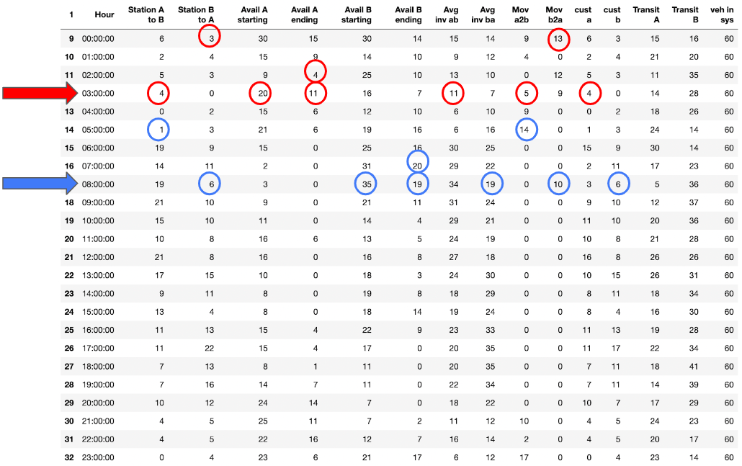

Calculation on random sample data:

Calculation for a few hours is shown below. All 24 hours calculations can be seen in appendix A.11.

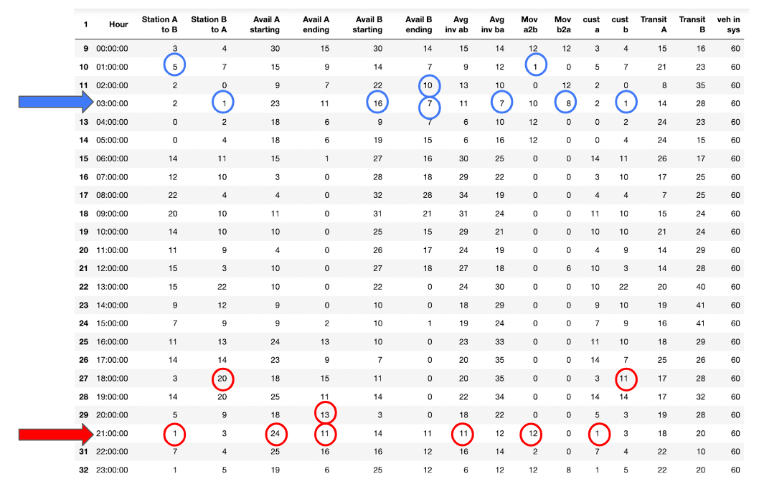

The summary of this policy is shown in the table below:

We tried multiple iterations with a service level of 80%, 90%, 95% and 99% and Review period of 1,2 and 3 hours. From the below table we can clearly say that highest profit and customer satisfaction can be achieved with 99% service level and 2 hrs of review period.

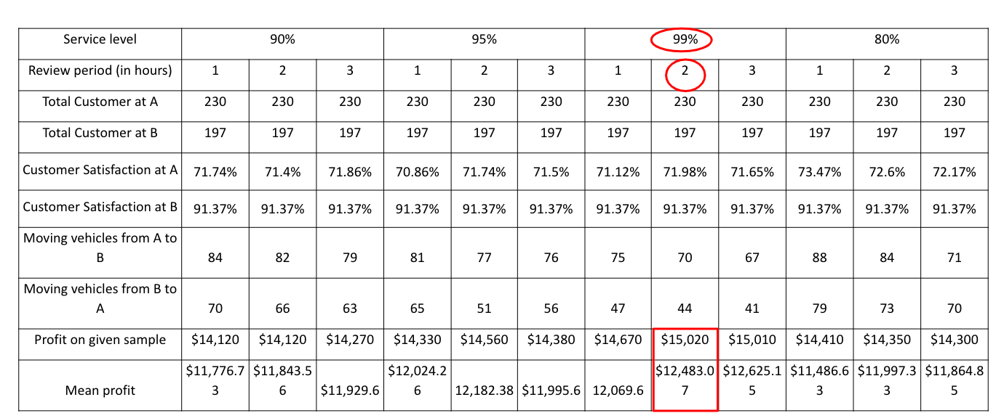

**4.1.4. Policy using future mean demand**

Vehicles were relocated from each station based on the demand occurring in the future using the given mean demand as reference. The code can be found in appendix A.12

For station A, if the available inventory after meeting the demand for that hour was greater than the total demand for the next three hours (using the mean), the difference was relocated.

Similarly, for station B, if the available inventory after meeting the demand for that hour was greater than the total demand for the next two hours (using the mean), the difference was relocated.

Ex: If at station A the available was 15, and the demand was 5, then 10 vehicles would remain. If the total demand for the next three hours was 6, then 4 vehicles were relocated.

This policy does **not** check whether or not the receiving station is able to meet its future demand.

The figure shown below depicts the calculation on the given sample using the base stock policy. Mean Station A to B and Mean Station B to A are the given mean demands for stations A and B, respectively. The total number of vehicles in the system is the sum of the available inventory at A and B and the vehicles in transit from A and B.

Calculation on given sample data:

Calculation for a few hours is shown below. All 24 hours calculations can be seen in appendix A.13.

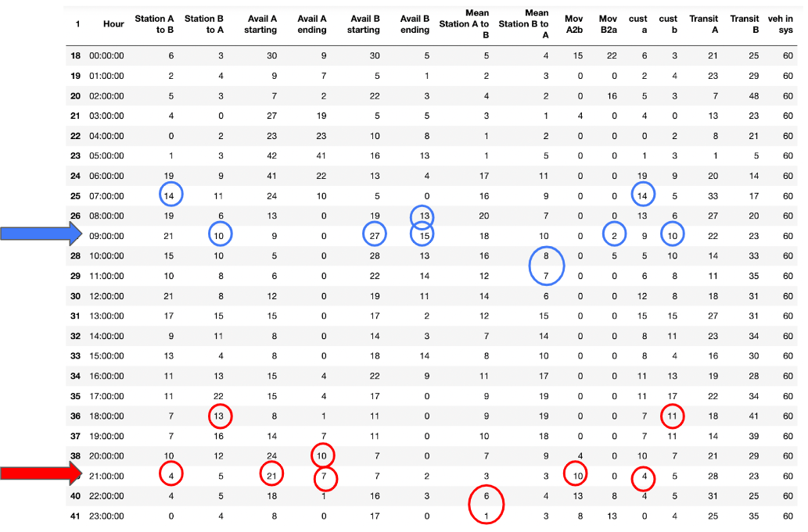

Calculation on random sample data:

Calculation for a few hours is shown below. All 24 hours calculations can be seen in appendix A.14.

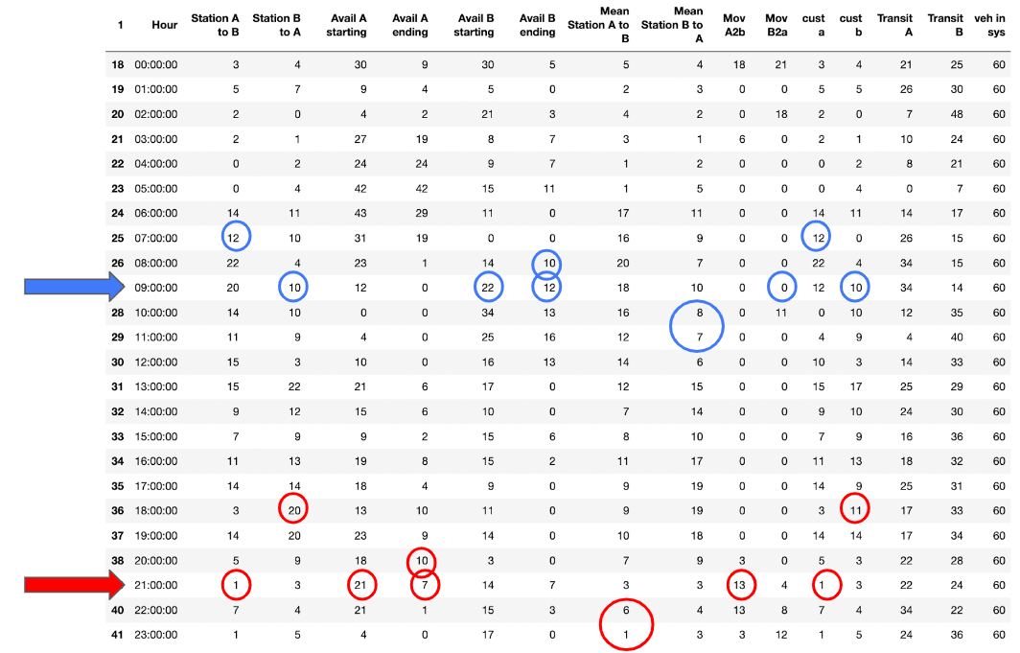

The summary of this policy on given sample data is shown in the table below:

| Station | A | B |
| --- | --- | --- |
| Total customer | 230 | 197 |
| Customer satisfaction | 79.03% | 83.25% |
| Moved vehicles | 54 | 66 |
| Average satisfaction | 80.96% | |

**4.1.5. Policy using future modified mean demand**

This policy modified the previous policy and considered if the receiving station could not meet its future demand. The code can be found in appendix A.15

For station A, if the available inventory after meeting the demand for that hour was greater than the total demand for the next three hours (using the mean), and if the available inventory at Station B after meeting the demand for that hour was lesser than the total demand for the next two hours.

Similarly, for station B, if the available inventory after meeting the demand for that hour was greater than the total demand for the next two hours (using the mean), and if the available inventory at Station A after meeting the demand for that hour was lesser than the total demand for the next three hours.

Ex: If at station A the available was 15, and the demand was 5, then 10 vehicles would remain. If the total demand for the next three hours was 6, then 4 vehicles were available to be relocated.

And if at station B the available was 7 and the demand was 5, then 2 vehicles would remain. If the total demand for the next two hours was greater than 2, then the 4 vehicles were relocated.

Calculator on the given sample data:

Calculation for a few hours is shown below. All 24 hours calculations can be seen in appendix A.16.

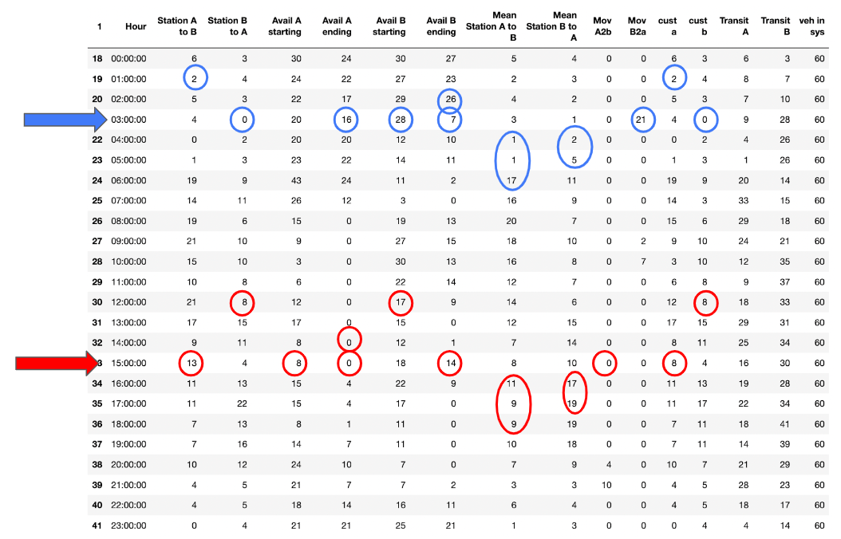

Calculation on Random sample data:

Calculation for a few hours is shown below. All 24 hours calculations can be seen in appendix A.17.

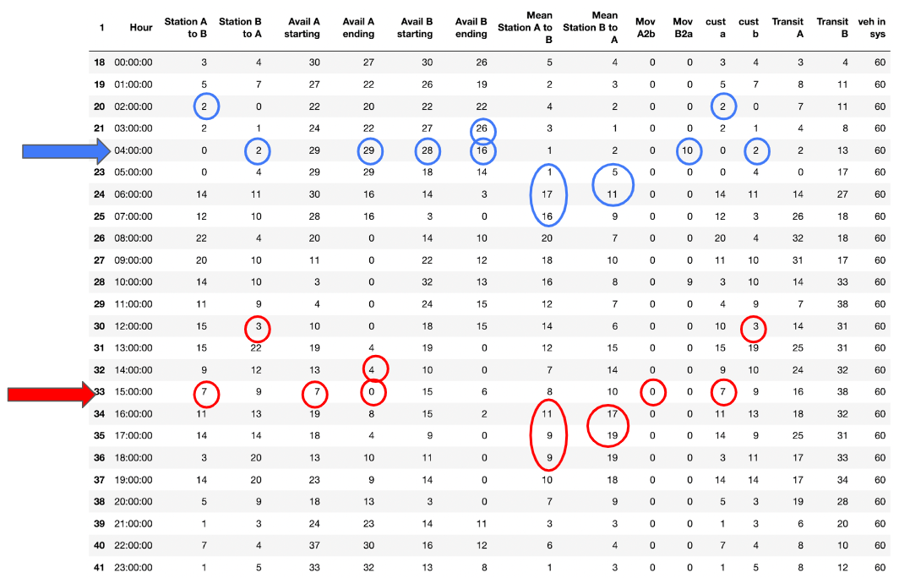

The summary of this policy on given sample data is shown in the table below:

| Station | A | B |
| --- | --- | --- |
| Total customer | 230 | 197 |
| Customer satisfaction | 76.95% | 91.37% |
| Moved vehicles | 14 | 29 |
| Average satisfaction | 83.45% | |

**5. Results**

| Policy | Customer satisfaction at A | Customer satisfaction at B | Moving Vehicles from A | Moving Vehicles from B | Profit on given sample | Mean profit on random sample |
| --- | --- | --- | --- | --- | --- | --- |
| No Policy | 70% | 91.37% | 0 | 0 | $17,280 | $15,882.5 |
| S,T policy based on stock value | 75.12% | 91.37% | 44 | 23 | $16,330 | $14,751.09 |
| S,T policy based on Avg. inventory value | 71.98% | 91.37% | 70 | 44 | $15,020 | $12,483.07 |
| Mean Future demand policy | 79.03% | 83.25% | 54 | 66 | $16,260 | $13,106.83 |
| Modified mean future demand policy | 76.95% | 91.37% | 14 | 29 | $18,080 | $16,273.2 |

**6. Conclusion:**

● The profit and customer satisfaction obtained for different policies were observed over 100 randomly generated samples.

● The Modified future mean policy is the most optimum, with maximum profit and high customer fulfillment.

●The future mean policy was expected to be the most profitable. Once you can foresee the expected future demand, it becomes easier to allocate and move vehicles between stations and satisfy customers' demands.

●The second-best policy is the No policy, where the system runs independently without any vehicle transfer between stations.

**Appendix**

**A.1 Code for sample generation**

dataframes_list = []

df = pd.read_excel('Project_Customer_Demand.xlsx')

df1 = pd.read_excel('Project_Customer_Demand.xlsx','Sample')

for j in range(1,100,1):

df_newsample = df.copy(deep=True)

for i in range(2,26,1):

df_newsample['Unnamed: 1'].iloc[i] = random.choice(np.random.poisson(df['Unnamed: 1'].iloc[i],10))

df_newsample['Unnamed: 2'].iloc[i] = random.choice(np.random.poisson(df['Unnamed: 2'].iloc[i],10))

dataframes_list.append(df_newsample)

**A.2 Randomly generated samples**

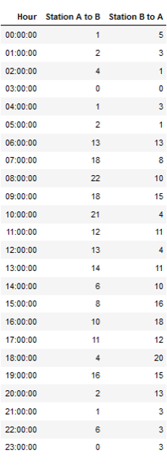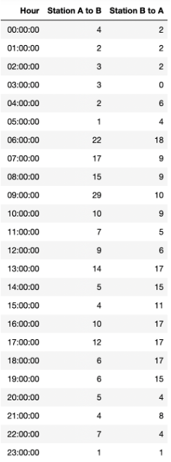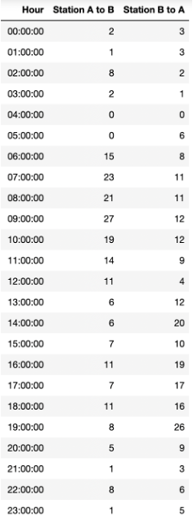

**A.3 - Code for no policy**

for k in range(0,len(dataframes_list),1):

temp_df = dataframes_list[k].copy(deep=True)

for i in range(3,27,1):

var=0

var2=0

temp_df['cust a'].iloc[i] = min(temp_df['Station A to B'].iloc[i],max(0,temp_df['Avail A ending'].iloc[i-1])+temp_df['cust b'].iloc[i-3])

temp_df['cust b'].iloc[i] = min(temp_df['Station B to A'].iloc[i],max(0,temp_df['Avail B ending'].iloc[i-1])+temp_df['cust a'].iloc[i-2])

temp_df['Avail A ending'].iloc[i] = max(0,temp_df['Avail A ending'].iloc[i-1]-temp_df['cust a'].iloc[i]+temp_df['cust b'].iloc[i-3])

temp_df['Avail B ending'].iloc[i] = max(0,temp_df['Avail B ending'].iloc[i-1]-temp_df['cust b'].iloc[i]+temp_df['cust a'].iloc[i-2])

temp_df['Avail A starting'].iloc[i] = temp_df['Avail A ending'].iloc[i-1]+temp_df['cust b'].iloc[i-3]+temp_df['Mov b2a'].iloc[i-3]

temp_df['Avail B starting'].iloc[i] = temp_df['Avail B ending'].iloc[i-1]+temp_df['cust a'].iloc[i-2]+temp_df['Mov a2b'].iloc[i-2]

temp_df['Transit A'].iloc[i] = temp_df['cust a'].iloc[i] + temp_df['cust a'].iloc[i-1]+temp_df['Mov a2b'].iloc[i]+temp_df['Mov a2b'].iloc[i-1]

temp_df['Transit B'].iloc[i] = temp_df['cust b'].iloc[i] + temp_df['cust b'].iloc[i-1]+ temp_df['cust b'].iloc[i-2]+temp_df['Mov b2a'].iloc[i]+temp_df['Mov b2a'].iloc[i-1]+temp_df['Mov b2a'].iloc[i-2]

dataframes_list[k] = temp_df.copy(deep=True)

for k in range(0,len(dataframes_list),1):

temp_df = dataframes_list[k].copy(deep=True)

for i in range(3,27,1):

temp_df['veh in sys'].iloc[i] = temp_df['Avail A ending'].iloc[i]+temp_df['Transit A'].iloc[i]+temp_df['Transit B'].iloc[i]+temp_df['Avail B ending'].iloc[i]

dataframes_list[k] = temp_df.copy(deep=True)

custA = []

custB = []

Profit = []

MovA = []

MovB = []

cus_sata = []

cus_satb = []

for i in range(0,len(dataframes_list),1):

ca = 0

cb = 0

da = 0

db = 0

ma = 0

mb = 0

profit = 0

ca = dataframes_list[i]['cust a'].sum()

cb = dataframes_list[i]['cust b'].sum()

da = dataframes_list[i]['Station A to B'].sum()

db = dataframes_list[i]['Station B to A'].sum()

pa = dataframes_list[i]['Station A to B'].sum()-dataframes_list[i]['cust a'].sum()

pb = dataframes_list[i]['Station B to A'].sum()-dataframes_list[i]['cust b'].sum()

csa = (ca)*100/(da)

csb = (cb)*100/(db)

cus_sata.append(csa)

cus_satb.append(csb)

profit = ca*60+cb*90-ma*20-mb*30-pa*100-pb*100

Profit.append(profit)

print(sum(Profit)/len(Profit))

print(Profit)

Profit_nopol = 0

Profit_nopol = sum(Profit)/len(Profit)

Pmean_nopol = 0

Pmean_nopol = Profit[0]

cusa_nopol = sum(cus_sata)/len(cus_sata)

cusb_nopol = sum(cus_satb)/len(cus_satb)

sample_nopol = Profit[1]

**A.4 Calculation on the given sample (No policy):**

**A.5 Calculation on randomly generated sample (No policy):**

**A.6 Code for S,T base stock policy with 99% service level and 2 hours of review period:**

Ultab = 4 #(T+Uab)

Ultba = 5 #(T+Uba)

sigABltr = 2 #sqrt(Uab+t)

sigBAltr = 2.236 #sqrt(3+1)

df_mean = dataframes_list[0]

df_mean['A2B U_DLTR'] = df_mean['Station A to B']*Ultab

df_mean['A2B Sig_DLTR'] = df_mean['Station A to B'].pow(1./2)*sigABltr

df_mean['B2A U_DLTR'] = df_mean['Station B to A']*Ultba

df_mean['B2A Sig_DLTR'] = df_mean['Station B to A'].pow(1./2)*sigBAltr

za = 2.58

nbar_s = 2.5815

df_mean['Sab'] = df_mean['A2B U_DLTR']+(za*df_mean['A2B Sig_DLTR'])

df_mean['Sba'] = df_mean['B2A U_DLTR']+(za*df_mean['B2A Sig_DLTR'])

df_mean['Avg inv ab'] = df_mean['Station A to B'].div(2)+(nbar_s*df_mean['A2B Sig_DLTR'])

df_mean['Avg inv ba'] = df_mean['Station B to A'].div(2)+(nbar_s*df_mean['B2A Sig_DLTR'])

df_mean['Avg inv ab'] = df_mean['Avg inv ab'].apply(np.ceil)

df_mean['Avg inv ba'] = df_mean['Avg inv ba'].apply(np.ceil)

df_mean['Sab'] = df_mean['Sab'].apply(np.ceil)

df_mean['Sba'] = df_mean['Sba'].apply(np.ceil)

df_mean['Mov a2b'] = 0

df_mean['Mov b2a'] = 0

df_mean['Transit A'] = 0

df_mean['Transit B'] = 0

#%%time

for k in range(0,len(dataframes_list),1):

temp_df = dataframes_list[k].copy(deep=True)

for i in range(3,27,1):

var=0

var2=0

if (temp_df['Avail A starting'].iloc[i]> df_mean['Sab'].iloc[i]) and (temp_df['Avail B starting'].iloc[i]>df_mean['Sba'].iloc[i]):

temp_df['cust a'].iloc[i] = min(temp_df['Station A to B'].iloc[i],max(0,temp_df['Avail A ending'].iloc[i-1])+temp_df['cust b'].iloc[i-3]+temp_df['Mov b2a'].iloc[i-3])

temp_df['cust b'].iloc[i] = min(temp_df['Station B to A'].iloc[i],max(0,temp_df['Avail B ending'].iloc[i-1])+temp_df['cust a'].iloc[i-2]+temp_df['Mov a2b'].iloc[i-2])

var = 0

var = max(0,temp_df['Avail B ending'].iloc[i-1]-temp_df['cust b'].iloc[i]-df_mean['Sba'].iloc[i]+ temp_df['Mov a2b'].iloc[i-2]+temp_df['cust a'].iloc[i-2])

temp_df['Mov b2a'].iloc[i] = var

temp_df['Avail A ending'].iloc[i] = max(0,temp_df['Avail A ending'].iloc[i-1]-temp_df['cust a'].iloc[i]+temp_df['cust b'].iloc[i-3]+temp_df['Mov b2a'].iloc[i-3]-temp_df['Mov a2b'].iloc[i])

temp_df['Avail B ending'].iloc[i] = max(0,temp_df['Avail B ending'].iloc[i-1]-temp_df['cust b'].iloc[i]+temp_df['cust a'].iloc[i-2]+temp_df['Mov a2b'].iloc[i-2]-temp_df['Mov b2a'].iloc[i])

var2 = 0

var2 = max(0,temp_df['Avail A ending'].iloc[i-1]-temp_df['cust a'].iloc[i]-df_mean['Sab'].iloc[i]+temp_df['Mov b2a'].iloc[i-3]+temp_df['cust b'].iloc[i-3])

temp_df['Mov a2b'].iloc[i] = var2

temp_df['Avail A ending'].iloc[i] = max(0,temp_df['Avail A ending'].iloc[i-1]-temp_df['cust a'].iloc[i]+temp_df['cust b'].iloc[i-3]+temp_df['Mov b2a'].iloc[i-3]-temp_df['Mov a2b'].iloc[i])

temp_df['Avail B ending'].iloc[i] = max(0,temp_df['Avail B ending'].iloc[i-1]-temp_df['cust b'].iloc[i]+temp_df['cust a'].iloc[i-2]+temp_df['Mov a2b'].iloc[i-2]-temp_df['Mov b2a'].iloc[i])

temp_df['Avail A starting'].iloc[i] = temp_df['Avail A ending'].iloc[i-1]+temp_df['cust b'].iloc[i-3]+temp_df['Mov b2a'].iloc[i-3]

temp_df['Avail B starting'].iloc[i] = temp_df['Avail B ending'].iloc[i-1]+temp_df['cust a'].iloc[i-2]+temp_df['Mov a2b'].iloc[i-2]

temp_df['Transit A'].iloc[i] = temp_df['cust a'].iloc[i] + temp_df['cust a'].iloc[i-1]+temp_df['Mov a2b'].iloc[i]+temp_df['Mov a2b'].iloc[i-1]

temp_df['Transit B'].iloc[i] = temp_df['cust b'].iloc[i] + temp_df['cust b'].iloc[i-1]+ temp_df['cust b'].iloc[i-2]+temp_df['Mov b2a'].iloc[i]+temp_df['Mov b2a'].iloc[i-1]+temp_df['Mov b2a'].iloc[i-2]

elif (temp_df['Avail A starting'].iloc[i]> df_mean['Sab'].iloc[i]):

temp_df['cust a'].iloc[i] = min(temp_df['Station A to B'].iloc[i],max(0,temp_df['Avail A ending'].iloc[i-1])+temp_df['cust b'].iloc[i-3]+temp_df['Mov b2a'].iloc[i-3])

temp_df['cust b'].iloc[i] = min(temp_df['Station B to A'].iloc[i],max(0,temp_df['Avail B ending'].iloc[i-1])+temp_df['cust a'].iloc[i-2]+temp_df['Mov a2b'].iloc[i-2])

var2 = 0

var2 = max(0,temp_df['Avail A ending'].iloc[i-1]-temp_df['cust a'].iloc[i]-df_mean['Sab'].iloc[i]+temp_df['Mov b2a'].iloc[i-3]+temp_df['cust b'].iloc[i-3])

temp_df['Mov a2b'].iloc[i] = var2

temp_df['Avail A ending'].iloc[i] = max(0,temp_df['Avail A ending'].iloc[i-1]-temp_df['cust a'].iloc[i]+temp_df['cust b'].iloc[i-3]+temp_df['Mov b2a'].iloc[i-3]-temp_df['Mov a2b'].iloc[i])

temp_df['Avail B ending'].iloc[i] = max(0,temp_df['Avail B ending'].iloc[i-1]-temp_df['cust b'].iloc[i]+temp_df['cust a'].iloc[i-2]+temp_df['Mov a2b'].iloc[i-2]-temp_df['Mov b2a'].iloc[i])

temp_df['Avail A starting'].iloc[i] = temp_df['Avail A ending'].iloc[i-1]+temp_df['cust b'].iloc[i-3]+temp_df['Mov b2a'].iloc[i-3]

temp_df['Avail B starting'].iloc[i] = temp_df['Avail B ending'].iloc[i-1]+temp_df['cust a'].iloc[i-2]+temp_df['Mov a2b'].iloc[i-2]

temp_df['Transit A'].iloc[i] = temp_df['cust a'].iloc[i] + temp_df['cust a'].iloc[i-1]+temp_df['Mov a2b'].iloc[i]+temp_df['Mov a2b'].iloc[i-1]

temp_df['Transit B'].iloc[i] = temp_df['cust b'].iloc[i] + temp_df['cust b'].iloc[i-1]+ temp_df['cust b'].iloc[i-2]+temp_df['Mov b2a'].iloc[i]+temp_df['Mov b2a'].iloc[i-1]+temp_df['Mov b2a'].iloc[i-2]

elif (temp_df['Avail B starting'].iloc[i]>df_mean['Sba'].iloc[i]):

temp_df['cust a'].iloc[i] = min(temp_df['Station A to B'].iloc[i],max(0,temp_df['Avail A ending'].iloc[i-1])+temp_df['cust b'].iloc[i-3]+temp_df['Mov b2a'].iloc[i-3])

temp_df['cust b'].iloc[i] = min(temp_df['Station B to A'].iloc[i],max(0,temp_df['Avail B ending'].iloc[i-1])+temp_df['cust a'].iloc[i-2]+temp_df['Mov a2b'].iloc[i-2])

var = 0

var = max(0,temp_df['Avail B ending'].iloc[i-1]-temp_df['cust b'].iloc[i]-df_mean['Sba'].iloc[i]+ temp_df['Mov a2b'].iloc[i-2]+temp_df['cust a'].iloc[i-2])

temp_df['Mov b2a'].iloc[i] = var

temp_df['Avail A ending'].iloc[i] = max(0,temp_df['Avail A ending'].iloc[i-1]-temp_df['cust a'].iloc[i]+temp_df['cust b'].iloc[i-3]+temp_df['Mov b2a'].iloc[i-3]-temp_df['Mov a2b'].iloc[i])

temp_df['Avail B ending'].iloc[i] = max(0,temp_df['Avail B ending'].iloc[i-1]-temp_df['cust b'].iloc[i]+temp_df['cust a'].iloc[i-2]+temp_df['Mov a2b'].iloc[i-2]-temp_df['Mov b2a'].iloc[i])

temp_df['Avail A starting'].iloc[i] = temp_df['Avail A ending'].iloc[i-1]+temp_df['cust b'].iloc[i-3]+temp_df['Mov b2a'].iloc[i-3]

temp_df['Avail B starting'].iloc[i] = temp_df['Avail B ending'].iloc[i-1]+temp_df['cust a'].iloc[i-2]+temp_df['Mov a2b'].iloc[i-2]

temp_df['Transit A'].iloc[i] = temp_df['cust a'].iloc[i] + temp_df['cust a'].iloc[i-1]+temp_df['Mov a2b'].iloc[i]+temp_df['Mov a2b'].iloc[i-1]

temp_df['Transit B'].iloc[i] = temp_df['cust b'].iloc[i] + temp_df['cust b'].iloc[i-1]+ temp_df['cust b'].iloc[i-2]+temp_df['Mov b2a'].iloc[i]+temp_df['Mov b2a'].iloc[i-1]+temp_df['Mov b2a'].iloc[i-2]

else:

temp_df['cust a'].iloc[i] = min(temp_df['Station A to B'].iloc[i],max(0,temp_df['Avail A ending'].iloc[i-1])+temp_df['cust b'].iloc[i-3]+temp_df['Mov b2a'].iloc[i-3])

temp_df['cust b'].iloc[i] = min(temp_df['Station B to A'].iloc[i],max(0,temp_df['Avail B ending'].iloc[i-1])+temp_df['cust a'].iloc[i-2]+temp_df['Mov a2b'].iloc[i-2])

temp_df['Avail A ending'].iloc[i] = max(0,temp_df['Avail A ending'].iloc[i-1]-temp_df['cust a'].iloc[i]+temp_df['cust b'].iloc[i-3]+temp_df['Mov b2a'].iloc[i-3]-temp_df['Mov a2b'].iloc[i])

temp_df['Avail B ending'].iloc[i] = max(0,temp_df['Avail B ending'].iloc[i-1]-temp_df['cust b'].iloc[i]+temp_df['cust a'].iloc[i-2]+temp_df['Mov a2b'].iloc[i-2]-temp_df['Mov b2a'].iloc[i])

temp_df['Avail A starting'].iloc[i] = temp_df['Avail A ending'].iloc[i-1]+temp_df['cust b'].iloc[i-3]+temp_df['Mov b2a'].iloc[i-3]

temp_df['Avail B starting'].iloc[i] = temp_df['Avail B ending'].iloc[i-1]+temp_df['cust a'].iloc[i-2]+temp_df['Mov a2b'].iloc[i-2]

temp_df['Transit A'].iloc[i] = temp_df['cust a'].iloc[i] + temp_df['cust a'].iloc[i-1]+temp_df['Mov a2b'].iloc[i]+temp_df['Mov a2b'].iloc[i-1]

temp_df['Transit B'].iloc[i] = temp_df['cust b'].iloc[i] + temp_df['cust b'].iloc[i-1]+ temp_df['cust b'].iloc[i-2]+temp_df['Mov b2a'].iloc[i]+temp_df['Mov b2a'].iloc[i-1]+temp_df['Mov b2a'].iloc[i-2]

dataframes_list[k] = temp_df.copy(deep=True)

for k in range(0,len(dataframes_list),1):

temp_df = dataframes_list[k].copy(deep=True)

for i in range(3,27,1):

temp_df['veh in sys'].iloc[i] = temp_df['Avail A ending'].iloc[i]+temp_df['Transit A'].iloc[i]+temp_df['Transit B'].iloc[i]+temp_df['Avail B ending'].iloc[i]

dataframes_list[k] = temp_df.copy(deep=True)

custA = []

cus_sata = []

cus_satb = []

custB = []

Profit = []

MovA = []

MovB = []

for i in range(0,len(dataframes_list),1):

ca = 0

cb = 0

ma = 0

mb = 0

profit = 0

ca = dataframes_list[i]['cust a'].sum()

cb = dataframes_list[i]['cust b'].sum()

da=dataframes_list[i]['Station A to B'].sum()

db=dataframes_list[i]['Station B to A'].sum()

csa = (ca)*100/(da)

csb = (cb)*100/(db)

cus_sata.append(csa)

cus_satb.append(csb)

ma = dataframes_list[i]['Mov a2b'].sum()

mb = dataframes_list[i]['Mov b2a'].sum()

pa = dataframes_list[i]['Station A to B'].sum()-dataframes_list[i]['cust a'].sum()

pb = dataframes_list[i]['Station B to A'].sum()-dataframes_list[i]['cust b'].sum()

profit = ca*60+cb*90-ma*20-mb*30-pa*100-pb*100

Profit.append(profit)

print(sum(Profit)/len(Profit))

print(Profit)

Profit_99_hr2 = 0

Profit_99_hr2 = sum(Profit)/len(Profit)

Pmean_99_hr2 = 0

Pmean_99_hr2 = Profit[0]

cusa_99_hr2 = sum(cus_sata)/len(cus_sata)

cusb_99_hr2 = sum(cus_satb)/len(cus_satb)

sample_99_hr2 = Profit[1]

**A.7 Calculation on the given sample (S, T base stock level policy):**



**A.8 Calculation on randomly generated sample (S,T base stock level policy):**



**A.9 code for S,T average stock level policy:**

for k in range(0,len(dataframes_list),1):

temp_df = dataframes_list[k].copy(deep=True)

for i in range(3,27,1):

var=0

var2=0

if (temp_df['Avail A starting'].iloc[i]> df_mean['Avg inv ab'].iloc[i]) and (temp_df['Avail B starting'].iloc[i]>df_mean['Avg inv ba'].iloc[i]):

temp_df['cust a'].iloc[i] = min(temp_df['Station A to B'].iloc[i],max(0,temp_df['Avail A ending'].iloc[i-1])+temp_df['cust b'].iloc[i-3]+temp_df['Mov b2a'].iloc[i-3])

temp_df['cust b'].iloc[i] = min(temp_df['Station B to A'].iloc[i],max(0,temp_df['Avail B ending'].iloc[i-1])+temp_df['cust a'].iloc[i-2]+temp_df['Mov a2b'].iloc[i-2])

var = 0

var = max(0,temp_df['Avail B ending'].iloc[i-1]-temp_df['cust b'].iloc[i]-df_mean['Avg inv ba'].iloc[i]+ temp_df['Mov a2b'].iloc[i-2]+temp_df['cust a'].iloc[i-2])

temp_df['Mov b2a'].iloc[i] = var

temp_df['Avail A ending'].iloc[i] = max(0,temp_df['Avail A ending'].iloc[i-1]-temp_df['cust a'].iloc[i]+temp_df['cust b'].iloc[i-3]+temp_df['Mov b2a'].iloc[i-3]-temp_df['Mov a2b'].iloc[i])

temp_df['Avail B ending'].iloc[i] = max(0,temp_df['Avail B ending'].iloc[i-1]-temp_df['cust b'].iloc[i]+temp_df['cust a'].iloc[i-2]+temp_df['Mov a2b'].iloc[i-2]-temp_df['Mov b2a'].iloc[i])

var2 = 0

var2 = max(0,temp_df['Avail A ending'].iloc[i-1]-temp_df['cust a'].iloc[i]-df_mean['Avg inv ab'].iloc[i]+temp_df['Mov b2a'].iloc[i-3]+temp_df['cust b'].iloc[i-3])

temp_df['Mov a2b'].iloc[i] = var2

temp_df['Avail A ending'].iloc[i] = max(0,temp_df['Avail A ending'].iloc[i-1]-temp_df['cust a'].iloc[i]+temp_df['cust b'].iloc[i-3]+temp_df['Mov b2a'].iloc[i-3]-temp_df['Mov a2b'].iloc[i])

temp_df['Avail B ending'].iloc[i] = max(0,temp_df['Avail B ending'].iloc[i-1]-temp_df['cust b'].iloc[i]+temp_df['cust a'].iloc[i-2]+temp_df['Mov a2b'].iloc[i-2]-temp_df['Mov b2a'].iloc[i])

temp_df['Avail A starting'].iloc[i] = temp_df['Avail A ending'].iloc[i-1]+temp_df['cust b'].iloc[i-3]+temp_df['Mov b2a'].iloc[i-3]

temp_df['Avail B starting'].iloc[i] = temp_df['Avail B ending'].iloc[i-1]+temp_df['cust a'].iloc[i-2]+temp_df['Mov a2b'].iloc[i-2]

temp_df['Transit A'].iloc[i] = temp_df['cust a'].iloc[i] + temp_df['cust a'].iloc[i-1]+temp_df['Mov a2b'].iloc[i]+temp_df['Mov a2b'].iloc[i-1]

temp_df['Transit B'].iloc[i] = temp_df['cust b'].iloc[i] + temp_df['cust b'].iloc[i-1]+ temp_df['cust b'].iloc[i-2]+temp_df['Mov b2a'].iloc[i]+temp_df['Mov b2a'].iloc[i-1]+temp_df['Mov b2a'].iloc[i-2]

elif (temp_df['Avail A starting'].iloc[i]> df_mean['Avg inv ab'].iloc[i]):

temp_df['cust a'].iloc[i] = min(temp_df['Station A to B'].iloc[i],max(0,temp_df['Avail A ending'].iloc[i-1])+temp_df['cust b'].iloc[i-3]+temp_df['Mov b2a'].iloc[i-3])

temp_df['cust b'].iloc[i] = min(temp_df['Station B to A'].iloc[i],max(0,temp_df['Avail B ending'].iloc[i-1])+temp_df['cust a'].iloc[i-2]+temp_df['Mov a2b'].iloc[i-2])

var2 = 0

var2 = max(0,temp_df['Avail A ending'].iloc[i-1]-temp_df['cust a'].iloc[i]-df_mean['Avg inv ab'].iloc[i]+temp_df['Mov b2a'].iloc[i-3]+temp_df['cust b'].iloc[i-3])

temp_df['Mov a2b'].iloc[i] = var2

temp_df['Avail A ending'].iloc[i] = max(0,temp_df['Avail A ending'].iloc[i-1]-temp_df['cust a'].iloc[i]+temp_df['cust b'].iloc[i-3]+temp_df['Mov b2a'].iloc[i-3]-temp_df['Mov a2b'].iloc[i])

temp_df['Avail B ending'].iloc[i] = max(0,temp_df['Avail B ending'].iloc[i-1]-temp_df['cust b'].iloc[i]+temp_df['cust a'].iloc[i-2]+temp_df['Mov a2b'].iloc[i-2]-temp_df['Mov b2a'].iloc[i])

temp_df['Avail A starting'].iloc[i] = temp_df['Avail A ending'].iloc[i-1]+temp_df['cust b'].iloc[i-3]+temp_df['Mov b2a'].iloc[i-3]

temp_df['Avail B starting'].iloc[i] = temp_df['Avail B ending'].iloc[i-1]+temp_df['cust a'].iloc[i-2]+temp_df['Mov a2b'].iloc[i-2]

temp_df['Transit A'].iloc[i] = temp_df['cust a'].iloc[i] + temp_df['cust a'].iloc[i-1]+temp_df['Mov a2b'].iloc[i]+temp_df['Mov a2b'].iloc[i-1]

temp_df['Transit B'].iloc[i] = temp_df['cust b'].iloc[i] + temp_df['cust b'].iloc[i-1]+ temp_df['cust b'].iloc[i-2]+temp_df['Mov b2a'].iloc[i]+temp_df['Mov b2a'].iloc[i-1]+temp_df['Mov b2a'].iloc[i-2]

elif (temp_df['Avail B starting'].iloc[i]>df_mean['Avg inv ba'].iloc[i]):

temp_df['cust a'].iloc[i] = min(temp_df['Station A to B'].iloc[i],max(0,temp_df['Avail A ending'].iloc[i-1])+temp_df['cust b'].iloc[i-3]+temp_df['Mov b2a'].iloc[i-3])

temp_df['cust b'].iloc[i] = min(temp_df['Station B to A'].iloc[i],max(0,temp_df['Avail B ending'].iloc[i-1])+temp_df['cust a'].iloc[i-2]+temp_df['Mov a2b'].iloc[i-2])

var = 0

var = max(0,temp_df['Avail B ending'].iloc[i-1]-temp_df['cust b'].iloc[i]-df_mean['Avg inv ba'].iloc[i]+ temp_df['Mov a2b'].iloc[i-2]+temp_df['cust a'].iloc[i-2])

temp_df['Mov b2a'].iloc[i] = var

temp_df['Avail A ending'].iloc[i] = max(0,temp_df['Avail A ending'].iloc[i-1]-temp_df['cust a'].iloc[i]+temp_df['cust b'].iloc[i-3]+temp_df['Mov b2a'].iloc[i-3]-temp_df['Mov a2b'].iloc[i])

temp_df['Avail B ending'].iloc[i] = max(0,temp_df['Avail B ending'].iloc[i-1]-temp_df['cust b'].iloc[i]+temp_df['cust a'].iloc[i-2]+temp_df['Mov a2b'].iloc[i-2]-temp_df['Mov b2a'].iloc[i])

temp_df['Avail A starting'].iloc[i] = temp_df['Avail A ending'].iloc[i-1]+temp_df['cust b'].iloc[i-3]+temp_df['Mov b2a'].iloc[i-3]

temp_df['Avail B starting'].iloc[i] = temp_df['Avail B ending'].iloc[i-1]+temp_df['cust a'].iloc[i-2]+temp_df['Mov a2b'].iloc[i-2]

temp_df['Transit A'].iloc[i] = temp_df['cust a'].iloc[i] + temp_df['cust a'].iloc[i-1]+temp_df['Mov a2b'].iloc[i]+temp_df['Mov a2b'].iloc[i-1]

temp_df['Transit B'].iloc[i] = temp_df['cust b'].iloc[i] + temp_df['cust b'].iloc[i-1]+ temp_df['cust b'].iloc[i-2]+temp_df['Mov b2a'].iloc[i]+temp_df['Mov b2a'].iloc[i-1]+temp_df['Mov b2a'].iloc[i-2]

else:

temp_df['cust a'].iloc[i] = min(temp_df['Station A to B'].iloc[i],max(0,temp_df['Avail A ending'].iloc[i-1])+temp_df['cust b'].iloc[i-3]+temp_df['Mov b2a'].iloc[i-3])

temp_df['cust b'].iloc[i] = min(temp_df['Station B to A'].iloc[i],max(0,temp_df['Avail B ending'].iloc[i-1])+temp_df['cust a'].iloc[i-2]+temp_df['Mov a2b'].iloc[i-2])

temp_df['Avail A ending'].iloc[i] = max(0,temp_df['Avail A ending'].iloc[i-1]-temp_df['cust a'].iloc[i]+temp_df['cust b'].iloc[i-3]+temp_df['Mov b2a'].iloc[i-3]-temp_df['Mov a2b'].iloc[i])

temp_df['Avail B ending'].iloc[i] = max(0,temp_df['Avail B ending'].iloc[i-1]-temp_df['cust b'].iloc[i]+temp_df['cust a'].iloc[i-2]+temp_df['Mov a2b'].iloc[i-2]-temp_df['Mov b2a'].iloc[i])

temp_df['Avail A starting'].iloc[i] = temp_df['Avail A ending'].iloc[i-1]+temp_df['cust b'].iloc[i-3]+temp_df['Mov b2a'].iloc[i-3]

temp_df['Avail B starting'].iloc[i] = temp_df['Avail B ending'].iloc[i-1]+temp_df['cust a'].iloc[i-2]+temp_df['Mov a2b'].iloc[i-2]

temp_df['Transit A'].iloc[i] = temp_df['cust a'].iloc[i] + temp_df['cust a'].iloc[i-1]+temp_df['Mov a2b'].iloc[i]+temp_df['Mov a2b'].iloc[i-1]

temp_df['Transit B'].iloc[i] = temp_df['cust b'].iloc[i] + temp_df['cust b'].iloc[i-1]+ temp_df['cust b'].iloc[i-2]+temp_df['Mov b2a'].iloc[i]+temp_df['Mov b2a'].iloc[i-1]+temp_df['Mov b2a'].iloc[i-2]

dataframes_list[k] = temp_df.copy(deep=True)

for k in range(0,len(dataframes_list),1):

temp_df = dataframes_list[k].copy(deep=True)

for i in range(3,27,1):

temp_df['veh in sys'].iloc[i] = temp_df['Avail A ending'].iloc[i]+temp_df['Transit A'].iloc[i]+temp_df['Transit B'].iloc[i]+temp_df['Avail B ending'].iloc[i]

dataframes_list[k] = temp_df.copy(deep=True)

custA = []

cus_sata = []

cus_satb = []

custB = []

Profit = []

MovA = []

MovB = []

for i in range(0,len(dataframes_list),1):

ca = 0

cb = 0

ma = 0

mb = 0

profit = 0

ca = dataframes_list[i]['cust a'].sum()

cb = dataframes_list[i]['cust b'].sum()

da=dataframes_list[i]['Station A to B'].sum()

db=dataframes_list[i]['Station B to A'].sum()

csa = (ca)*100/(da)

csb = (cb)*100/(db)

cus_sata.append(csa)

cus_satb.append(csb)

ma = dataframes_list[i]['Mov a2b'].sum()

mb = dataframes_list[i]['Mov b2a'].sum()

pa = dataframes_list[i]['Station A to B'].sum()-dataframes_list[i]['cust a'].sum()

pb = dataframes_list[i]['Station B to A'].sum()-dataframes_list[i]['cust b'].sum()

profit = ca*60+cb*90-ma*20-mb*30-pa*100-pb*100

Profit.append(profit)

**A.10 Calculation on given sample (S,T average stock level policy):**



**A.11 Calculation on the randomly generated sample (S, T Averages stock level policy):**



**A.12 Code for Future mean demand policy:**

mean_df = dataframes_list[0].copy(deep=True)

mean_df.loc[len(mean_df)] = 0

mean_df.loc[len(mean_df)] = 0

mean_df.loc[len(mean_df)] = 0

mean_df = mean_df.rename(columns={'Mov a2b':'Mov A2b','Mov b2a':'Mov B2a'}).copy(deep=True)

for i in range(0,len(dataframes_list),1):

temp_df = dataframes_list[i].copy(deep=True)

for j in range(3,27,1):

if (temp_df['Avail B ending'].iloc[j-1]+temp_df['cust a'].iloc[j-2]+temp_df['Mov A2b'].iloc[j-2]-temp_df['cust b'].iloc[j]>mean_df['Station B to A'].iloc[j+1]+mean_df['Station B to A'].iloc[j+2]) and (temp_df['Avail A ending'].iloc[j-1]+temp_df['cust b'].iloc[j-3]+temp_df['Mov B2a'].iloc[j-3]-temp_df['cust a'].iloc[j]<mean_df['Station A to B'].iloc[j+1]+mean_df['Station A to B'].iloc[j+2]+mean_df['Station A to B'].iloc[j+3]) and (temp_df['Avail A ending'].iloc[j-1]+temp_df['cust b'].iloc[j-3]+temp_df['Mov B2a'].iloc[j-3]-temp_df['cust a'].iloc[j]>mean_df['Station A to B'].iloc[j+1]+mean_df['Station A to B'].iloc[j+2]+mean_df['Station A to B'].iloc[j+3]) and (temp_df['Avail B ending'].iloc[j-1]+temp_df['cust a'].iloc[j-2]+temp_df['Mov A2b'].iloc[j-2]-temp_df['cust b'].iloc[j]<mean_df['Station B to A'].iloc[j+1]+mean_df['Station B to A'].iloc[j+2]):

temp_df['cust a'].iloc[j] = min(max(0,temp_df['Avail A ending'].iloc[j-1])+temp_df['cust b'].iloc[j-3]+temp_df['Mov B2a'].iloc[j-3],temp_df['Station A to B'].iloc[j])

temp_df['cust b'].iloc[j] = min(max(0,temp_df['Avail B ending'].iloc[j-1])+temp_df['cust a'].iloc[j-2]+temp_df['Mov A2b'].iloc[j-2],temp_df['Station B to A'].iloc[j])

moveA2B = 0

moveB2A = 0

temp_df['Avail A starting'].iloc[j] = temp_df['Avail A ending'].iloc[j-1]+temp_df['cust b'].iloc[j-3]+temp_df['Mov B2a'].iloc[j-3]

temp_df['Avail B starting'].iloc[j] = temp_df['Avail B ending'].iloc[j-1]+temp_df['cust a'].iloc[j-2]+temp_df['Mov A2b'].iloc[j-2]

temp_df['Mov A2b'].iloc[j] = max(0,temp_df['Avail A ending'].iloc[j-1]+temp_df['cust b'].iloc[j-3] +temp_df['Mov B2a'].iloc[j-3]-temp_df['cust a'].iloc[j]-mean_df['Station A to B'].iloc[j+1] - mean_df['Station A to B'].iloc[j+2] - mean_df['Station A to B'].iloc[j+3])

temp_df['Mov B2a'].iloc[j] = max(0,temp_df['Avail B ending'].iloc[j-1]+temp_df['cust a'].iloc[j-2]+temp_df['Mov A2b'].iloc[j-2]-temp_df['cust b'].iloc[j]-mean_df['Station B to A'].iloc[j+1]-mean_df['Station B to A'].iloc[j+2])

temp_df['Avail A ending'].iloc[j] = max(0,temp_df['Avail A ending'].iloc[j-1]-temp_df['cust a'].iloc[j]+temp_df['cust b'].iloc[j-3]-temp_df['Mov A2b'].iloc[j]+temp_df['Mov B2a'].iloc[j-3])

temp_df['Avail B ending'].iloc[j] = max(0,temp_df['Avail B ending'].iloc[j-1]-temp_df['cust b'].iloc[j]+temp_df['cust a'].iloc[j-2]-temp_df['Mov B2a'].iloc[j]+temp_df['Mov A2b'].iloc[j-2])

temp_df['Transit A'].iloc[j] = temp_df['cust a'].iloc[j] + temp_df['cust a'].iloc[j-1]+temp_df['Mov A2b'].iloc[j]+temp_df['Mov A2b'].iloc[j-1]

temp_df['Transit B'].iloc[j] = temp_df['cust b'].iloc[j] + temp_df['cust b'].iloc[j-1]+ temp_df['cust b'].iloc[j-2]+temp_df['Mov B2a'].iloc[j]+temp_df['Mov B2a'].iloc[j-1]+temp_df['Mov B2a'].iloc[j-2]

elif (temp_df['Avail A ending'].iloc[j-1]+temp_df['cust b'].iloc[j-3]+temp_df['Mov B2a'].iloc[j-3]-temp_df['cust a'].iloc[j]>mean_df['Station A to B'].iloc[j+1]+mean_df['Station A to B'].iloc[j+2]+mean_df['Station A to B'].iloc[j+3]) and (temp_df['Avail B ending'].iloc[j-1]+temp_df['cust b'].iloc[j-2]+temp_df['Mov A2b'].iloc[j-2]-temp_df['cust b'].iloc[j]<mean_df['Station B to A'].iloc[j+1]+mean_df['Station B to A'].iloc[j+2]):

moveA2B = 0

moveB2A = 0

temp_df['Avail A starting'].iloc[j] = temp_df['Avail A ending'].iloc[j-1]+temp_df['cust b'].iloc[j-3]+temp_df['Mov B2a'].iloc[j-3]

temp_df['Avail B starting'].iloc[j] = temp_df['Avail B ending'].iloc[j-1]+temp_df['cust a'].iloc[j-2]+temp_df['Mov A2b'].iloc[j-2]

temp_df['cust a'].iloc[j] = min(max(0,temp_df['Avail A ending'].iloc[j-1])+temp_df['cust b'].iloc[j-3]+temp_df['Mov B2a'].iloc[j-3],temp_df['Station A to B'].iloc[j])

temp_df['cust b'].iloc[j] = min(max(0,temp_df['Avail B ending'].iloc[j-1])+temp_df['cust a'].iloc[j-2]+temp_df['Mov A2b'].iloc[j-2],temp_df['Station B to A'].iloc[j])

temp_df['Mov A2b'].iloc[j] = max(0,temp_df['Avail A ending'].iloc[j-1]+temp_df['cust b'].iloc[j-3] +temp_df['Mov B2a'].iloc[j-3]-temp_df['cust a'].iloc[j]-mean_df['Station A to B'].iloc[j+1] - mean_df['Station A to B'].iloc[j+2] - mean_df['Station A to B'].iloc[j+3])

temp_df['Avail A ending'].iloc[j] = max(0,temp_df['Avail A ending'].iloc[j-1]-temp_df['cust a'].iloc[j]+temp_df['cust b'].iloc[j-3]-temp_df['Mov A2b'].iloc[j]+temp_df['Mov B2a'].iloc[j-3])

temp_df['Avail B ending'].iloc[j] = max(0,temp_df['Avail B ending'].iloc[j-1]-temp_df['cust b'].iloc[j]+temp_df['cust a'].iloc[j-2]-temp_df['Mov B2a'].iloc[j]+temp_df['Mov A2b'].iloc[j-2])

temp_df['Transit A'].iloc[j] = temp_df['cust a'].iloc[j] + temp_df['cust a'].iloc[j-1]+temp_df['Mov A2b'].iloc[j]+temp_df['Mov A2b'].iloc[j-1]

temp_df['Transit B'].iloc[j] = temp_df['cust b'].iloc[j] + temp_df['cust b'].iloc[j-1]+ temp_df['cust b'].iloc[j-2]+temp_df['Mov B2a'].iloc[j]+temp_df['Mov B2a'].iloc[j-1]+temp_df['Mov B2a'].iloc[j-2]

elif (temp_df['Avail B ending'].iloc[j-1]+temp_df['cust a'].iloc[j-2]+temp_df['Mov A2b'].iloc[j-2]-temp_df['cust b'].iloc[j]>mean_df['Station B to A'].iloc[j+1]+mean_df['Station B to A'].iloc[j+2]) and (temp_df['Avail A ending'].iloc[j-1]+temp_df['cust b'].iloc[j-3]+temp_df['Mov B2a'].iloc[j-3]-temp_df['cust a'].iloc[j]<mean_df['Station A to B'].iloc[j+1]+mean_df['Station A to B'].iloc[j+2]+mean_df['Station A to B'].iloc[j+3]):

moveA2B = 0

moveB2A = 0

temp_df['Avail A starting'].iloc[j] = temp_df['Avail A ending'].iloc[j-1]+temp_df['cust b'].iloc[j-3]+temp_df['Mov B2a'].iloc[j-3]

temp_df['Avail B starting'].iloc[j] = temp_df['Avail B ending'].iloc[j-1]+temp_df['cust a'].iloc[j-2]+temp_df['Mov A2b'].iloc[j-2]

temp_df['cust a'].iloc[j] = min(max(0,temp_df['Avail A ending'].iloc[j-1])+temp_df['cust b'].iloc[j-3]+temp_df['Mov B2a'].iloc[j-3],temp_df['Station A to B'].iloc[j])

temp_df['cust b'].iloc[j] = min(max(0,temp_df['Avail B ending'].iloc[j-1])+temp_df['cust a'].iloc[j-2]+temp_df['Mov A2b'].iloc[j-2],temp_df['Station B to A'].iloc[j])

temp_df['Mov B2a'].iloc[j] = max(0,temp_df['Avail B ending'].iloc[j-1]+temp_df['cust a'].iloc[j-2]+temp_df['Mov A2b'].iloc[j-2]-temp_df['cust b'].iloc[j]-mean_df['Station B to A'].iloc[j+1]-mean_df['Station B to A'].iloc[j+2])

temp_df['Avail A ending'].iloc[j] = max(0,temp_df['Avail A ending'].iloc[j-1]-temp_df['cust a'].iloc[j]+temp_df['cust b'].iloc[j-3]-temp_df['Mov A2b'].iloc[j]+temp_df['Mov B2a'].iloc[j-3])

temp_df['Avail B ending'].iloc[j] = max(0,temp_df['Avail B ending'].iloc[j-1]-temp_df['cust b'].iloc[j]+temp_df['cust a'].iloc[j-2]-temp_df['Mov B2a'].iloc[j]+temp_df['Mov A2b'].iloc[j-2])

temp_df['Transit A'].iloc[j] = temp_df['cust a'].iloc[j] + temp_df['cust a'].iloc[j-1]+temp_df['Mov A2b'].iloc[j]+temp_df['Mov A2b'].iloc[j-1]

temp_df['Transit B'].iloc[j] = temp_df['cust b'].iloc[j] + temp_df['cust b'].iloc[j-1]+ temp_df['cust b'].iloc[j-2]+temp_df['Mov B2a'].iloc[j]+temp_df['Mov B2a'].iloc[j-1]+temp_df['Mov B2a'].iloc[j-2]

else:

moveA2B = 0

moveB2A = 0

temp_df['Avail A starting'].iloc[j] = temp_df['Avail A ending'].iloc[j-1]+temp_df['cust b'].iloc[j-3]+temp_df['Mov B2a'].iloc[j-3]

temp_df['Avail B starting'].iloc[j] = temp_df['Avail B ending'].iloc[j-1]+temp_df['cust a'].iloc[j-2]+temp_df['Mov A2b'].iloc[j-2]

temp_df['cust a'].iloc[j] = min(max(0,temp_df['Avail A ending'].iloc[j-1])+temp_df['cust b'].iloc[j-3]+temp_df['Mov B2a'].iloc[j-3],temp_df['Station A to B'].iloc[j])

temp_df['cust b'].iloc[j] = min(max(0,temp_df['Avail B ending'].iloc[j-1])+temp_df['cust a'].iloc[j-2]+temp_df['Mov A2b'].iloc[j-2],temp_df['Station B to A'].iloc[j])

temp_df['Mov B2a'].iloc[j] = moveB2A

temp_df['Mov A2b'].iloc[j] = moveA2B

temp_df['Avail A ending'].iloc[j] = max(0,temp_df['Avail A ending'].iloc[j-1]-temp_df['cust a'].iloc[j]+temp_df['cust b'].iloc[j-3]-temp_df['Mov A2b'].iloc[j]+temp_df['Mov B2a'].iloc[j-3])

temp_df['Avail B ending'].iloc[j] = max(0,temp_df['Avail B ending'].iloc[j-1]-temp_df['cust b'].iloc[j]+temp_df['cust a'].iloc[j-2]-temp_df['Mov B2a'].iloc[j]+temp_df['Mov A2b'].iloc[j-2])

temp_df['Transit A'].iloc[j] = temp_df['cust a'].iloc[j] + temp_df['cust a'].iloc[j-1]+temp_df['Mov A2b'].iloc[j]+temp_df['Mov A2b'].iloc[j-1]

temp_df['Transit B'].iloc[j] = temp_df['cust b'].iloc[j] + temp_df['cust b'].iloc[j-1]+ temp_df['cust b'].iloc[j-2]+temp_df['Mov B2a'].iloc[j]+temp_df['Mov B2a'].iloc[j-1]+temp_df['Mov B2a'].iloc[j-2]

dataframes_list[i] = temp_df.copy(deep=True)

for k in range(0,len(dataframes_list),1):

temp_df = dataframes_list[k].copy(deep=True)

for i in range(3,27,1):

temp_df['veh in sys'].iloc[i] = temp_df['Avail A ending'].iloc[i]+temp_df['Transit A'].iloc[i]+temp_df['Transit B'].iloc[i]+temp_df['Avail B ending'].iloc[i]

dataframes_list[k] = temp_df.copy(deep=True)

cus_sata =[]

cus_satb =[]

Profit = []

for i in range(0,len(dataframes_list),1):

ca = 0

cb = 0

ma = 0

mb = 0

profit = 0

ca = dataframes_list[i]['cust a'].sum()

cb = dataframes_list[i]['cust b'].sum()

da=dataframes_list[i]['Station A to B'].sum()

db=dataframes_list[i]['Station B to A'].sum()

csa = (ca)*100/(da)

csb = (cb)*100/(db)

cus_sata.append(csa)

cus_satb.append(csb)

ma = dataframes_list[i]['Mov A2b'].sum()

mb = dataframes_list[i]['Mov B2a'].sum()

pa = dataframes_list[i]['Station A to B'].sum()-dataframes_list[i]['cust a'].sum()

pb = dataframes_list[i]['Station B to A'].sum()-dataframes_list[i]['cust b'].sum()

profit = ca*60+cb*90-ma*20-mb*30-pa*100-pb*100

Profit.append(profit)

**A.13 Calculation on given sample (Future mean demand policy):**



**A.14 Calculation on randomly generated sample (Future mean demand policy):**



**A.15 Code for Modified future mean demand policy:**

for i in range(0,len(dataframes_list),1):

temp_df = dataframes_list[i].copy(deep=True)

for j in range(3,27,1):

if (temp_df['Avail B ending'].iloc[j-1]+temp_df['cust a'].iloc[j-2]+temp_df['Mov A2b'].iloc[j-2]-temp_df['cust b'].iloc[j]>mean_df['Station B to A'].iloc[j+1]+mean_df['Station B to A'].iloc[j+2]) and (temp_df['Avail A ending'].iloc[j-1]+temp_df['cust b'].iloc[j-3]+temp_df['Mov B2a'].iloc[j-3]-temp_df['cust a'].iloc[j]>mean_df['Station A to B'].iloc[j+1]+mean_df['Station A to B'].iloc[j+2]+mean_df['Station A to B'].iloc[j+3]):

temp_df['cust a'].iloc[j] = min(max(0,temp_df['Avail A ending'].iloc[j-1])+temp_df['cust b'].iloc[j-3]+temp_df['Mov B2a'].iloc[j-3],temp_df['Station A to B'].iloc[j])

temp_df['cust b'].iloc[j] = min(max(0,temp_df['Avail B ending'].iloc[j-1])+temp_df['cust a'].iloc[j-2]+temp_df['Mov A2b'].iloc[j-2],temp_df['Station B to A'].iloc[j])

moveA2B = 0

moveB2A = 0

temp_df['Avail A starting'].iloc[j] = temp_df['Avail A ending'].iloc[j-1]+temp_df['cust b'].iloc[j-3]+temp_df['Mov B2a'].iloc[j-3]

temp_df['Avail B starting'].iloc[j] = temp_df['Avail B ending'].iloc[j-1]+temp_df['cust a'].iloc[j-2]+temp_df['Mov A2b'].iloc[j-2]

temp_df['Mov A2b'].iloc[j] = max(0,temp_df['Avail A ending'].iloc[j-1]+temp_df['cust b'].iloc[j-3] +temp_df['Mov B2a'].iloc[j-3]-temp_df['cust a'].iloc[j]-mean_df['Station A to B'].iloc[j+1] - mean_df['Station A to B'].iloc[j+2] - mean_df['Station A to B'].iloc[j+3])

temp_df['Mov B2a'].iloc[j] = max(0,temp_df['Avail B ending'].iloc[j-1]+temp_df['cust a'].iloc[j-2]+temp_df['Mov A2b'].iloc[j-2]-temp_df['cust b'].iloc[j]-mean_df['Station B to A'].iloc[j+1]-mean_df['Station B to A'].iloc[j+2])

temp_df['Avail A ending'].iloc[j] = max(0,temp_df['Avail A ending'].iloc[j-1]-temp_df['cust a'].iloc[j]+temp_df['cust b'].iloc[j-3]-temp_df['Mov A2b'].iloc[j]+temp_df['Mov B2a'].iloc[j-3])

temp_df['Avail B ending'].iloc[j] = max(0,temp_df['Avail B ending'].iloc[j-1]-temp_df['cust b'].iloc[j]+temp_df['cust a'].iloc[j-2]-temp_df['Mov B2a'].iloc[j]+temp_df['Mov A2b'].iloc[j-2])

temp_df['Transit A'].iloc[j] = temp_df['cust a'].iloc[j] + temp_df['cust a'].iloc[j-1]+temp_df['Mov A2b'].iloc[j]+temp_df['Mov A2b'].iloc[j-1]

temp_df['Transit B'].iloc[j] = temp_df['cust b'].iloc[j] + temp_df['cust b'].iloc[j-1]+ temp_df['cust b'].iloc[j-2]+temp_df['Mov B2a'].iloc[j]+temp_df['Mov B2a'].iloc[j-1]+temp_df['Mov B2a'].iloc[j-2]

elif (temp_df['Avail A ending'].iloc[j-1]+temp_df['cust b'].iloc[j-3]+temp_df['Mov B2a'].iloc[j-3]-temp_df['cust a'].iloc[j]>mean_df['Station A to B'].iloc[j+1]+mean_df['Station A to B'].iloc[j+2]+mean_df['Station A to B'].iloc[j+3]):

moveA2B = 0

moveB2A = 0

temp_df['Avail A starting'].iloc[j] = temp_df['Avail A ending'].iloc[j-1]+temp_df['cust b'].iloc[j-3]+temp_df['Mov B2a'].iloc[j-3]

temp_df['Avail B starting'].iloc[j] = temp_df['Avail B ending'].iloc[j-1]+temp_df['cust a'].iloc[j-2]+temp_df['Mov A2b'].iloc[j-2]

temp_df['cust a'].iloc[j] = min(max(0,temp_df['Avail A ending'].iloc[j-1])+temp_df['cust b'].iloc[j-3]+temp_df['Mov B2a'].iloc[j-3],temp_df['Station A to B'].iloc[j])

temp_df['cust b'].iloc[j] = min(max(0,temp_df['Avail B ending'].iloc[j-1])+temp_df['cust a'].iloc[j-2]+temp_df['Mov A2b'].iloc[j-2],temp_df['Station B to A'].iloc[j])

temp_df['Mov A2b'].iloc[j] = max(0,temp_df['Avail A ending'].iloc[j-1]+temp_df['cust b'].iloc[j-3] +temp_df['Mov B2a'].iloc[j-3]-temp_df['cust a'].iloc[j]-mean_df['Station A to B'].iloc[j+1] - mean_df['Station A to B'].iloc[j+2] - mean_df['Station A to B'].iloc[j+3])

temp_df['Avail A ending'].iloc[j] = max(0,temp_df['Avail A ending'].iloc[j-1]-temp_df['cust a'].iloc[j]+temp_df['cust b'].iloc[j-3]-temp_df['Mov A2b'].iloc[j]+temp_df['Mov B2a'].iloc[j-3])

temp_df['Avail B ending'].iloc[j] = max(0,temp_df['Avail B ending'].iloc[j-1]-temp_df['cust b'].iloc[j]+temp_df['cust a'].iloc[j-2]-temp_df['Mov B2a'].iloc[j]+temp_df['Mov A2b'].iloc[j-2])

temp_df['Transit A'].iloc[j] = temp_df['cust a'].iloc[j] + temp_df['cust a'].iloc[j-1]+temp_df['Mov A2b'].iloc[j]+temp_df['Mov A2b'].iloc[j-1]

temp_df['Transit B'].iloc[j] = temp_df['cust b'].iloc[j] + temp_df['cust b'].iloc[j-1]+ temp_df['cust b'].iloc[j-2]+temp_df['Mov B2a'].iloc[j]+temp_df['Mov B2a'].iloc[j-1]+temp_df['Mov B2a'].iloc[j-2]

elif (temp_df['Avail B ending'].iloc[j-1]+temp_df['cust a'].iloc[j-2]+temp_df['Mov A2b'].iloc[j-2]-temp_df['cust b'].iloc[j]>mean_df['Station B to A'].iloc[j+1]+mean_df['Station B to A'].iloc[j+2]):

moveA2B = 0

moveB2A = 0

temp_df['Avail A starting'].iloc[j] = temp_df['Avail A ending'].iloc[j-1]+temp_df['cust b'].iloc[j-3]+temp_df['Mov B2a'].iloc[j-3]

temp_df['Avail B starting'].iloc[j] = temp_df['Avail B ending'].iloc[j-1]+temp_df['cust a'].iloc[j-2]+temp_df['Mov A2b'].iloc[j-2]

temp_df['cust a'].iloc[j] = min(max(0,temp_df['Avail A ending'].iloc[j-1])+temp_df['cust b'].iloc[j-3]+temp_df['Mov B2a'].iloc[j-3],temp_df['Station A to B'].iloc[j])

temp_df['cust b'].iloc[j] = min(max(0,temp_df['Avail B ending'].iloc[j-1])+temp_df['cust a'].iloc[j-2]+temp_df['Mov A2b'].iloc[j-2],temp_df['Station B to A'].iloc[j])

temp_df['Mov B2a'].iloc[j] = max(0,temp_df['Avail B ending'].iloc[j-1]+temp_df['cust a'].iloc[j-2]+temp_df['Mov A2b'].iloc[j-2]-temp_df['cust b'].iloc[j]-mean_df['Station B to A'].iloc[j+1]-mean_df['Station B to A'].iloc[j+2])

temp_df['Avail A ending'].iloc[j] = max(0,temp_df['Avail A ending'].iloc[j-1]-temp_df['cust a'].iloc[j]+temp_df['cust b'].iloc[j-3]-temp_df['Mov A2b'].iloc[j]+temp_df['Mov B2a'].iloc[j-3])

temp_df['Avail B ending'].iloc[j] = max(0,temp_df['Avail B ending'].iloc[j-1]-temp_df['cust b'].iloc[j]+temp_df['cust a'].iloc[j-2]-temp_df['Mov B2a'].iloc[j]+temp_df['Mov A2b'].iloc[j-2])

temp_df['Transit A'].iloc[j] = temp_df['cust a'].iloc[j] + temp_df['cust a'].iloc[j-1]+temp_df['Mov A2b'].iloc[j]+temp_df['Mov A2b'].iloc[j-1]

temp_df['Transit B'].iloc[j] = temp_df['cust b'].iloc[j] + temp_df['cust b'].iloc[j-1]+ temp_df['cust b'].iloc[j-2]+temp_df['Mov B2a'].iloc[j]+temp_df['Mov B2a'].iloc[j-1]+temp_df['Mov B2a'].iloc[j-2]

else:

moveA2B = 0

moveB2A = 0

temp_df['Avail A starting'].iloc[j] = temp_df['Avail A ending'].iloc[j-1]+temp_df['cust b'].iloc[j-3]+temp_df['Mov B2a'].iloc[j-3]

temp_df['Avail B starting'].iloc[j] = temp_df['Avail B ending'].iloc[j-1]+temp_df['cust a'].iloc[j-2]+temp_df['Mov A2b'].iloc[j-2]

temp_df['cust a'].iloc[j] = min(max(0,temp_df['Avail A ending'].iloc[j-1])+temp_df['cust b'].iloc[j-3]+temp_df['Mov B2a'].iloc[j-3],temp_df['Station A to B'].iloc[j])

temp_df['cust b'].iloc[j] = min(max(0,temp_df['Avail B ending'].iloc[j-1])+temp_df['cust a'].iloc[j-2]+temp_df['Mov A2b'].iloc[j-2],temp_df['Station B to A'].iloc[j])

temp_df['Mov B2a'].iloc[j] = moveB2A

temp_df['Mov A2b'].iloc[j] = moveA2B

temp_df['Avail A ending'].iloc[j] = max(0,temp_df['Avail A ending'].iloc[j-1]-temp_df['cust a'].iloc[j]+temp_df['cust b'].iloc[j-3]-temp_df['Mov A2b'].iloc[j]+temp_df['Mov B2a'].iloc[j-3])

temp_df['Avail B ending'].iloc[j] = max(0,temp_df['Avail B ending'].iloc[j-1]-temp_df['cust b'].iloc[j]+temp_df['cust a'].iloc[j-2]-temp_df['Mov B2a'].iloc[j]+temp_df['Mov A2b'].iloc[j-2])

temp_df['Transit A'].iloc[j] = temp_df['cust a'].iloc[j] + temp_df['cust a'].iloc[j-1]+temp_df['Mov A2b'].iloc[j]+temp_df['Mov A2b'].iloc[j-1]

temp_df['Transit B'].iloc[j] = temp_df['cust b'].iloc[j] + temp_df['cust b'].iloc[j-1]+ temp_df['cust b'].iloc[j-2]+temp_df['Mov B2a'].iloc[j]+temp_df['Mov B2a'].iloc[j-1]+temp_df['Mov B2a'].iloc[j-2]

dataframes_list[i] = temp_df.copy(deep=True)

for k in range(0,len(dataframes_list),1):

temp_df = dataframes_list[k].copy(deep=True)

for i in range(3,27,1):

temp_df['veh in sys'].iloc[i] = temp_df['Avail A ending'].iloc[i]+temp_df['Transit A'].iloc[i]+temp_df['Transit B'].iloc[i]+temp_df['Avail B ending'].iloc[i]

dataframes_list[k] = temp_df.copy(deep=True)

cus_sata = []

cus_satb = []

Profit = []

for i in range(0,len(dataframes_list),1):

ca = 0

cb = 0

ma = 0

mb = 0

profit = 0

ca = dataframes_list[i]['cust a'].sum()

cb = dataframes_list[i]['cust b'].sum()

ma = dataframes_list[i]['Mov A2b'].sum()

mb = dataframes_list[i]['Mov B2a'].sum()

csa = (ca)*100/(da)

csb = (cb)*100/(db)

cus_sata.append(csa)

cus_satb.append(csb)

pa = dataframes_list[i]['Station A to B'].sum()-dataframes_list[i]['cust a'].sum()

pb = dataframes_list[i]['Station B to A'].sum()-dataframes_list[i]['cust b'].sum()

profit = ca*60+cb*90-ma*20-mb*30-pa*100-pb*100

Profit.append(profit)

**A.16 Calculation on given sample (Modified future mean demand policy):**

**A.17 Calculation on randomly generated sample (Modified future mean demand policy):**

